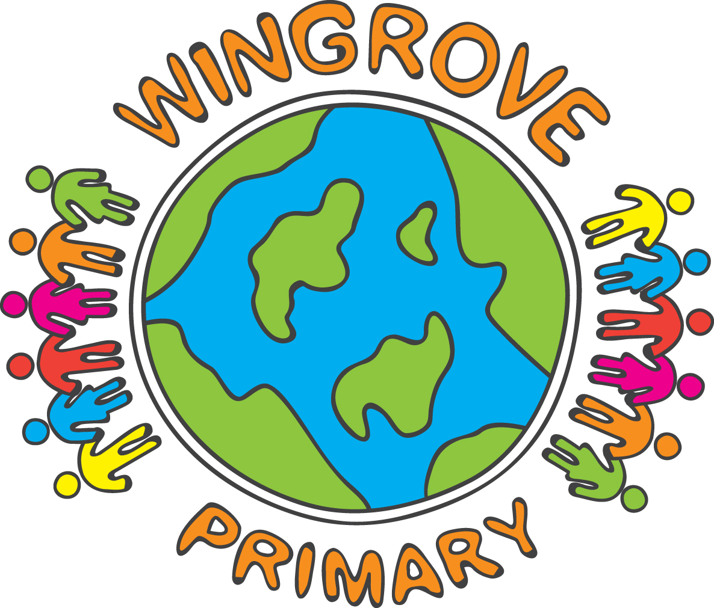

WINGROVE PRIMARY SCHOOL

Operating a halal kitchen

As part of our Chinese New Year celebrations, we will have a Chinese lunch on
Thursday 23rd January.

The menu will be:

Chinese Style Sweet and Sour Chicken Curry
Or
Quorn Curry

With

Fluffy Rice, Egg Noodles

Dessert

Ice Cream or Fresh Fruit Salad or Fortune Cookie

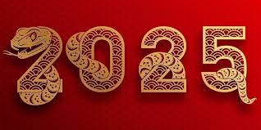
Chinese New Year

Lunch is being paid for by school. We will need numbers, however. We assume all children will be having a Chinese lunch, unless you tell us otherwise.

There will be no alternative meal served that day. Those children who would prefer to bring in their own packed lunch, may, of course, do so.

Thank you.

